July 2019 Sam unit located at Mundesley Rd (Outgoing Traffic) and August 2019 Sam unit located at Bradfield Rd 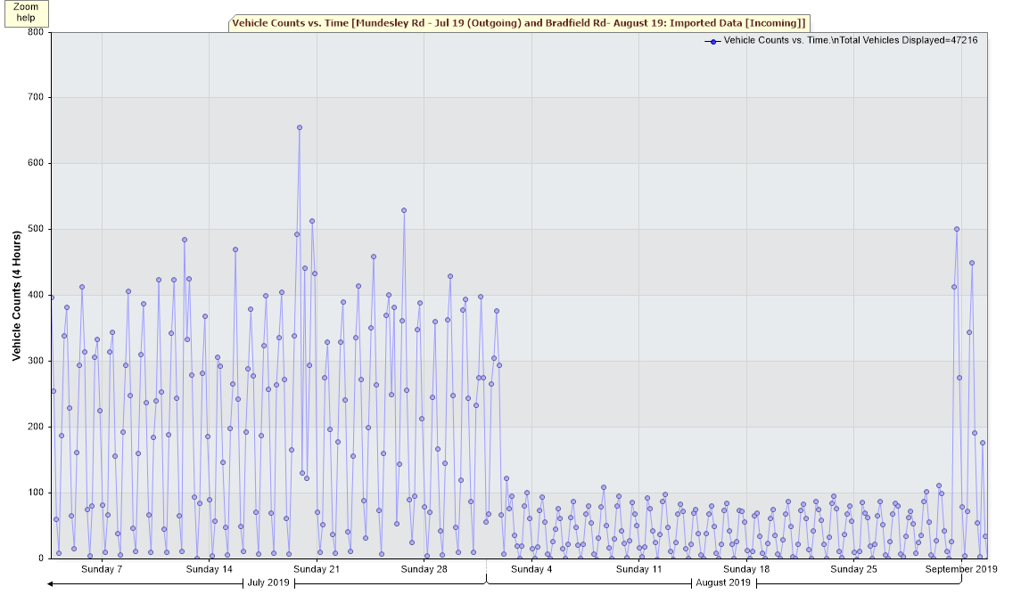

July 2019 Sam unit located at Mundesley Rd (Outgoing Traffic) and August 2019 Sam unit located at Bradfield Rd 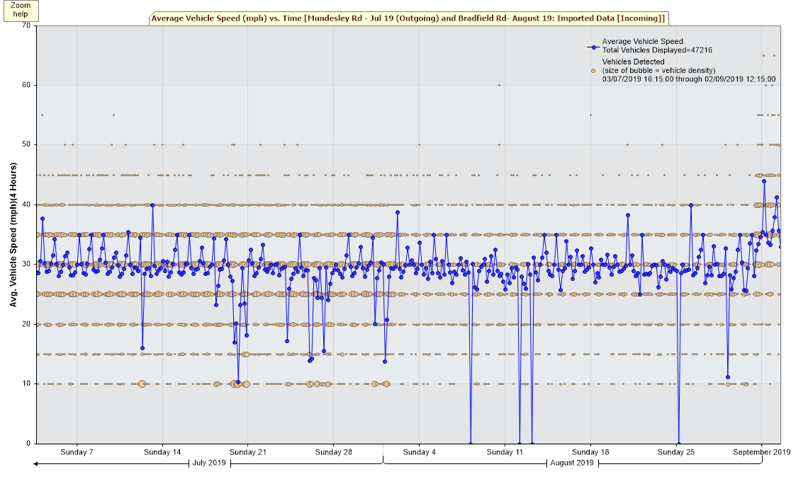
July 2019 Sam unit located at Mundesley Rd (Outgoing Traffic) and August 2019 Sam unit located at Bradfield Rd 