September 2019 – Sam unit located at Gables Ave end of Upper Southrepps, Incoming Traffic 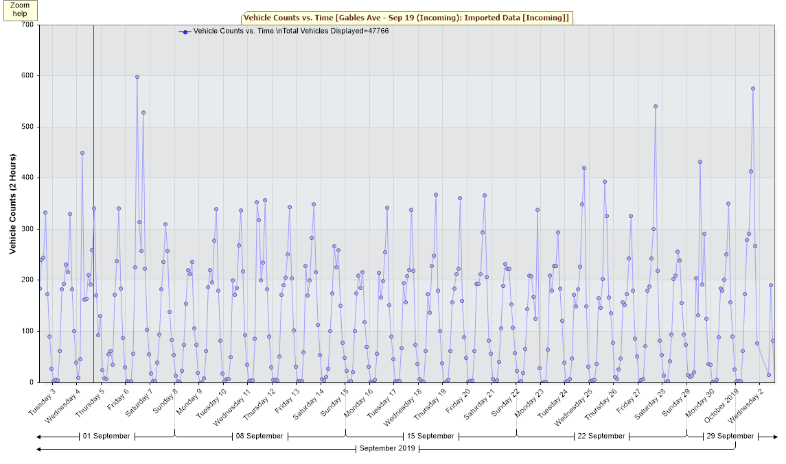

September 2019 – Sam unit located at Gables Ave end of Upper Southrepps, Incoming Traffic 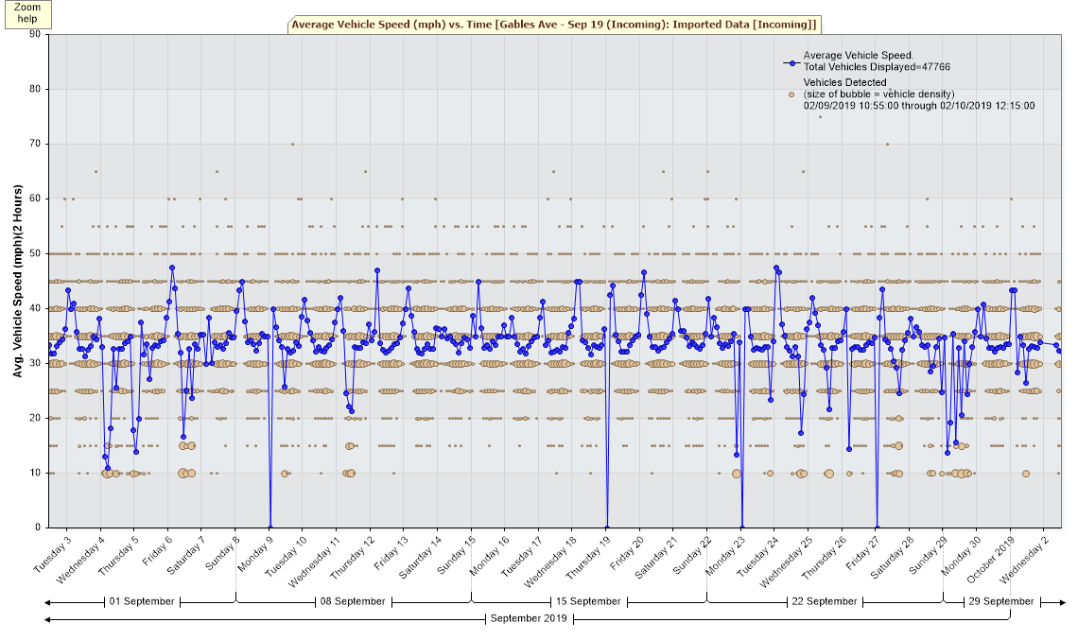
September 2019 – Sam unit located at Gables Ave end of Upper Southrepps, Incoming Traffic 